Admin logout pe confirmation honi chaye

Admin me right upper corner p profile photo k click p kuch nahi hai

There should be search option in admin panel, the search will return page links with readable titles like we search in windows setting

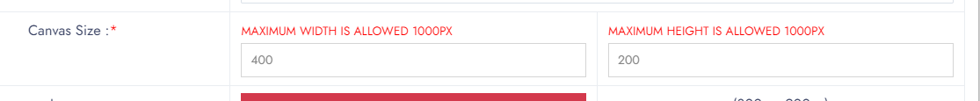

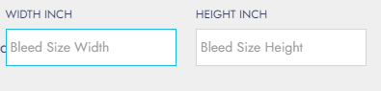

Ye inch me q hain ? jbke hr jaga pixels me hai sizes

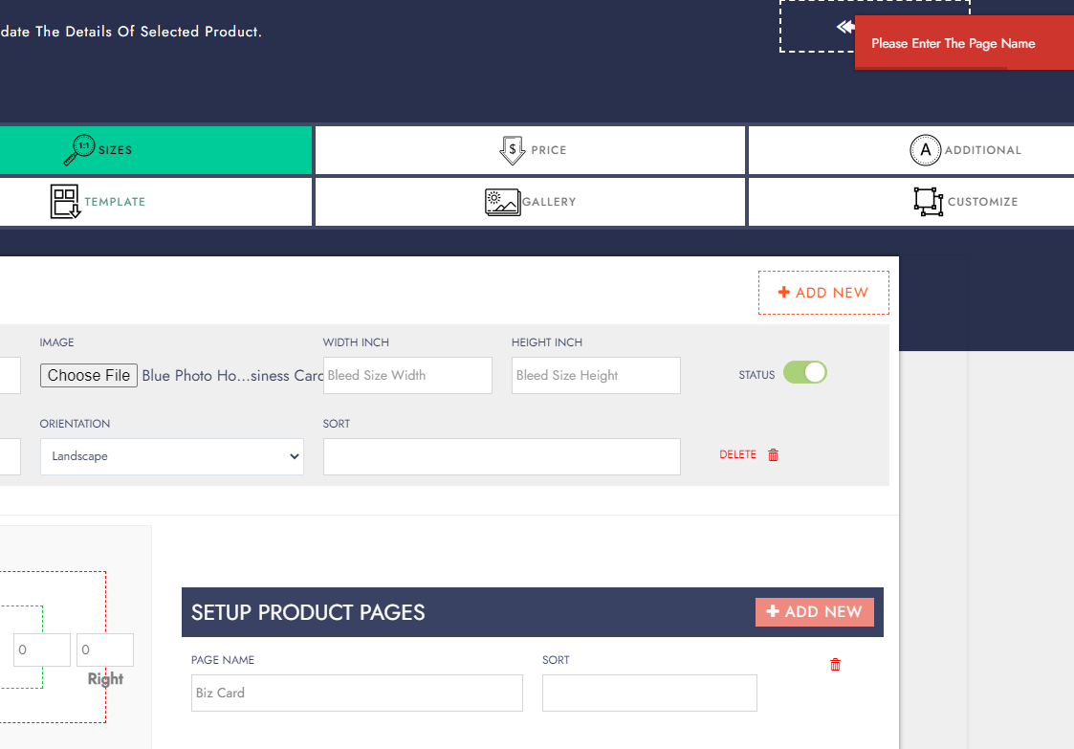

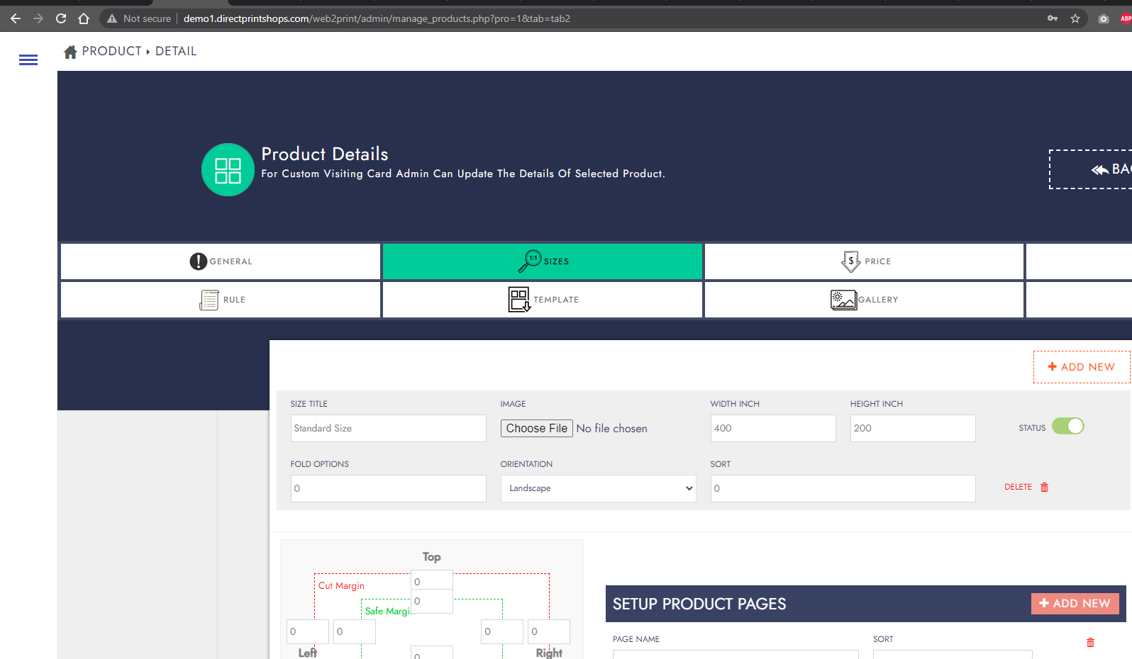

Is page p kae dafa save p click kia phir save hua I think koi loader nahi laga hua qk image ka size bara tha wo upload ho rhi hogi



These buttons do not have right pointer

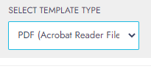

Pdf k agy acrobate reader q hai? I think iski zrort nahi

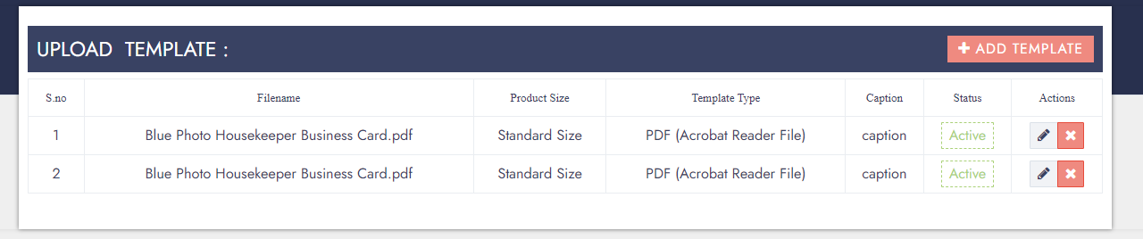

Ye mene eek bar add kia tha lekin do add hogaye qk save pe kae bar click krna para qk koi loader wgera nahi ata save pe kahi bhi

Gallery me product ki multiple images ek sath add nahi ho skti

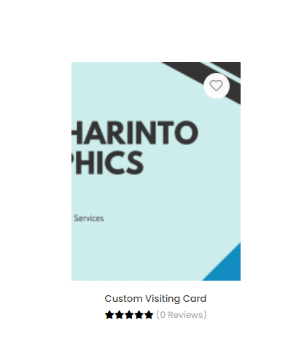

Product add krty hue ek thumbnail image bhi honi chaye

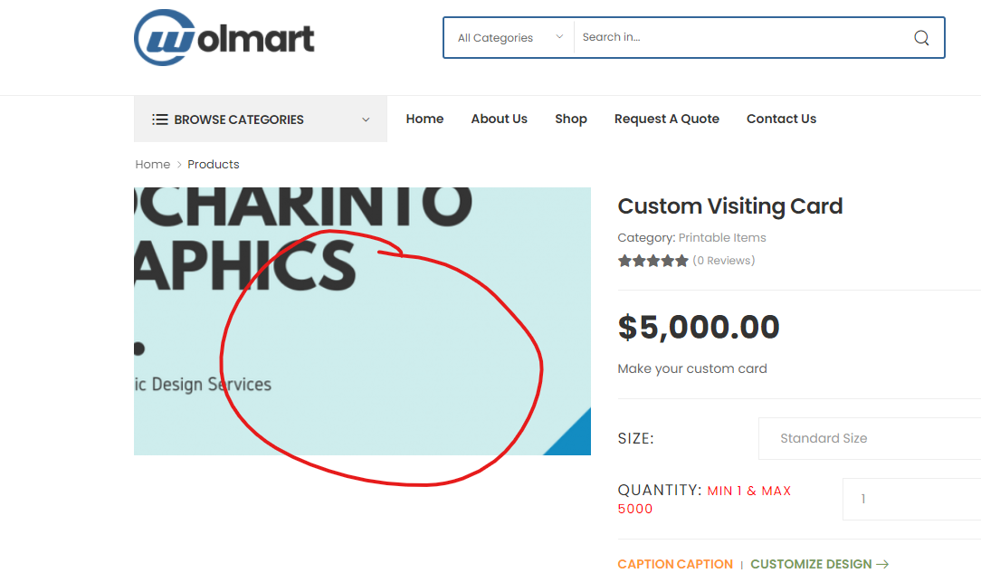

Yaha pointer ki jaga magnifying glass hona chaye ye zror kro demo se pehly

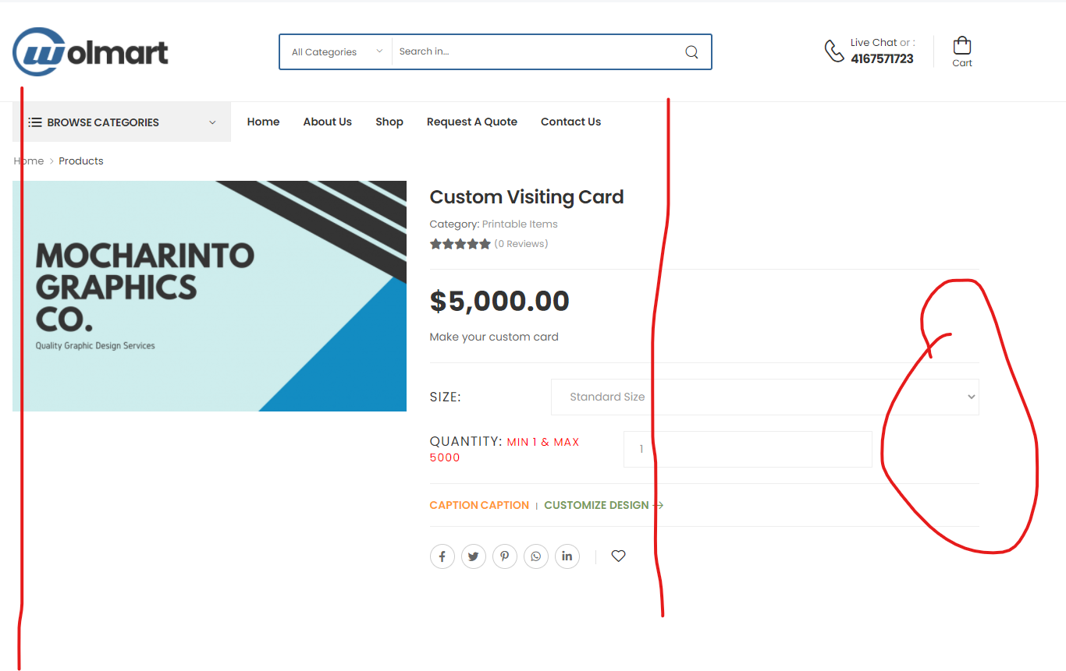

Baqi sb ek line me hai lekin ye size wala alag se bahir ja raha h ye bhi abhi sahi krna hai



Iske click pe new page me doc ya jo b ho wo new tab me Khulna chaye

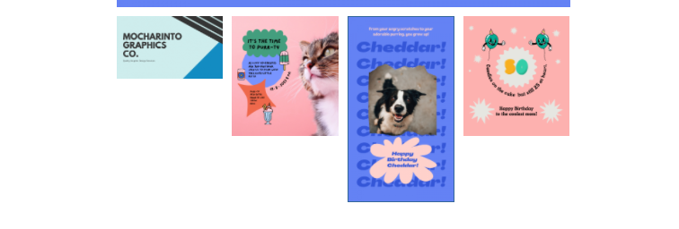

Ye ese sahi ni lg rhy sb ek he row me any chaye ese choty bry nahi (agar size ka issue hai tou admin side p restrict kro k same size k daly ye ali se bhi discuss krna lekin abhi esa kro k sb ek se size me dikhy )

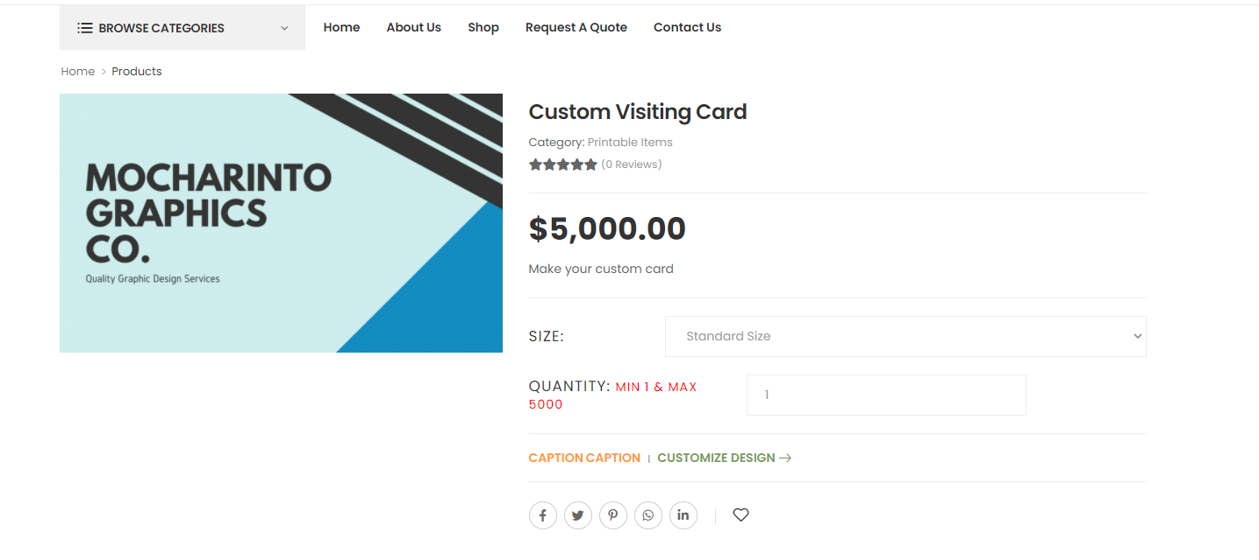

Textboxes and other components are not visible (pheky pheky h bht sahi se dikh nahi rhy design maze ka nahi lg raha is waja se )

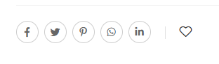

Not working

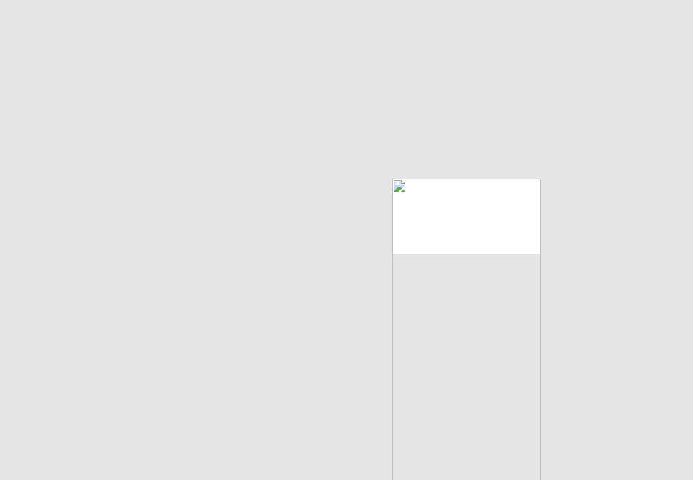

Designer studio me esa a raha h jbke mene template file d hui h I think mene pdf me d thi islye nahi I yaha

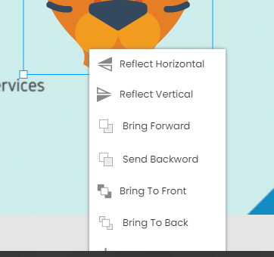

Ye menu gaib ho jata hai

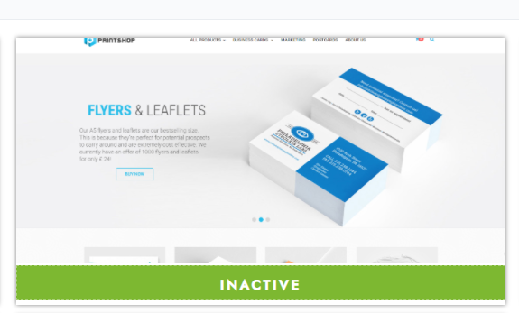

Hover pe text change ho k active ya activate hona chaye

Theme change pe slider wgera sb ja raha hai ali se pochna ese theek hai ya nahi

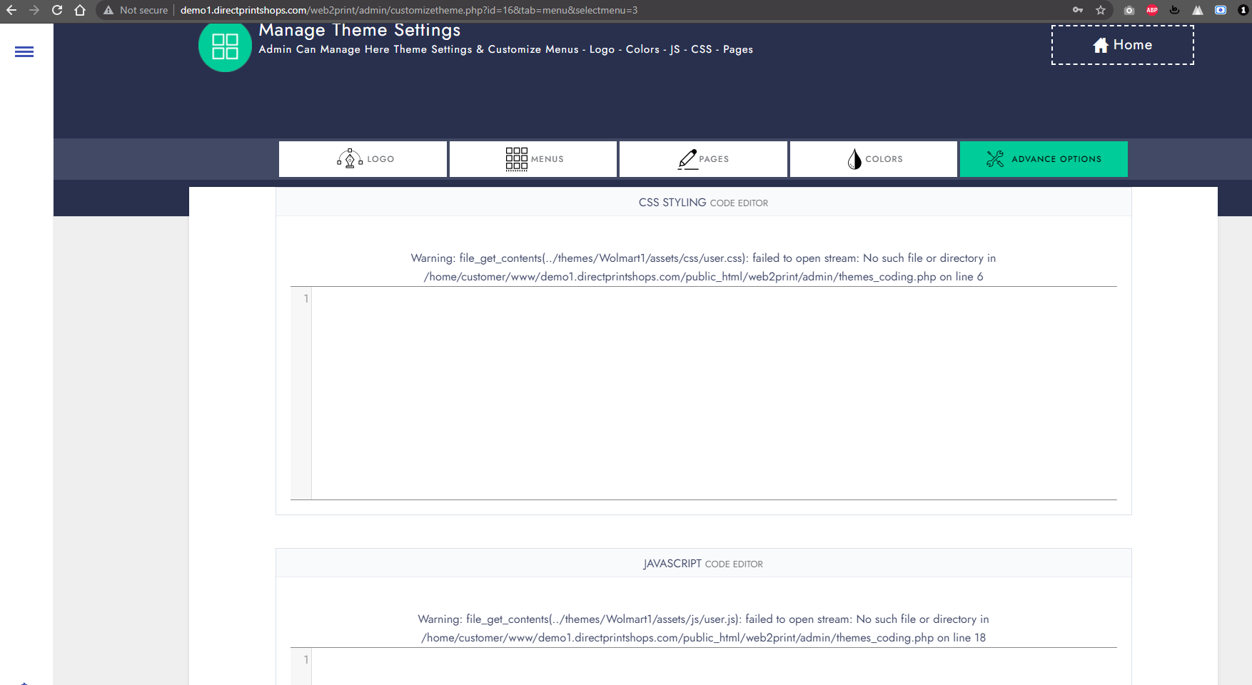

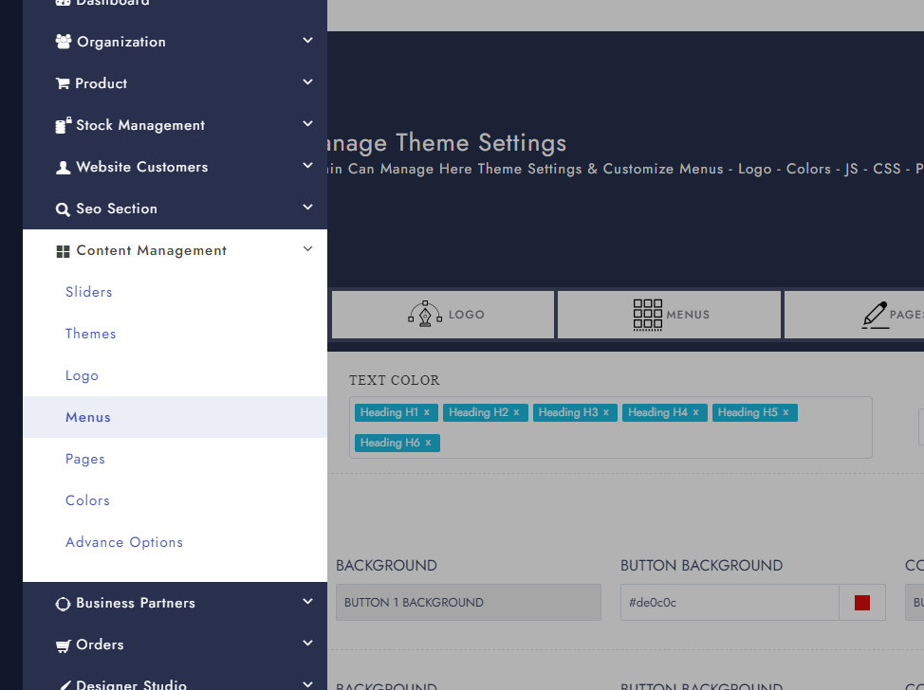

Jis menu pe hn wo select hua wa hona chaye

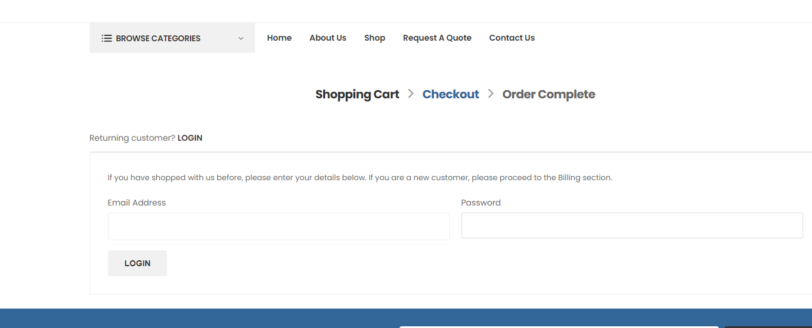

Checkout pe signup ka option nahi hai

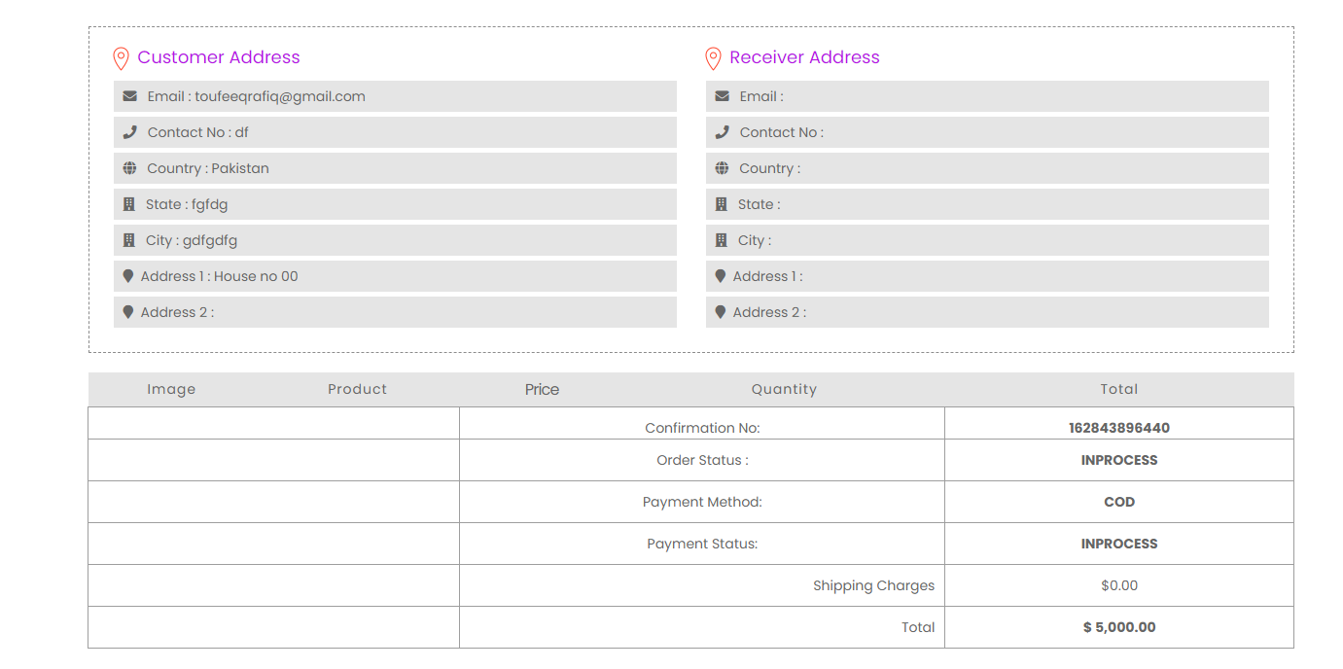

Print ya save ka option hona chaye

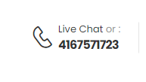

Ye email pe ja raha hai jbke hai phone num

Live chat jb hai nahi tou show bhi nahi honi chaye